Advances in Electronic Sensoring Through High-tech fabrics Intelligent Systems (ETSHIS)

D. I. Tseles, T.E.I. Piraeus, dtsel@teipir.gr

Abstract

Progress in personal monitoring health systems is presented is this paper. Acquisition of biological signals can be realized through wearable embedded systems, that are based on microcontrollers and RF modems. The wireless sensors networks technology has been adapted for implementation of Body Sensor Networks (BSN). A novel data acquisition system has been designed and implemented in order to acquire body physiological parameters measurements. Emergency call possibility is also considered. Development of an innovative software leads to diagnosis schemes through detection of abnormal arrhythmia incidents. This progress to the development of a standard model for monitoring patients remotely gives results that push research to improve patient’s safety.

Key Words

personal monitoring health systems, wearable embedded systems, wirelles sensor network, data acquisition systems, ECG diagnosis.

- Introduction

Personal monitoring health systems are able to monitor older people or patients at risk of life-threatening situations such as arrhythmias or cardiac failure and wearable health monitoring systems seem to be the future trend in disease management. The term "disease management" is nowadays one of the most commonly used words in the healthcare environment, and seems to be the future expectation for medical applications with the ambition not only to provide improved quality of care but also to achieve patient follow up, disease surveillance and on the top of all, an intervention in an acute incidence. [G. Priniotakis, E. Kapsalis, D. Tseles, A. Tzerachoglou, I. Chronis, D. Piromalis. (2009), G. Priniotakis, E. Kapsalis, D. Tseles, A. Tzerachoglou, D. Piromalis (13 – 15 November 2008), D. Piromalis, D. I. Tseles, G. Priniotakis, I. Chronis, V. Kapsalis (2007)]
Some cardiac patients need only routine follow up as their regular therapy while others require intensive follow-up such as patients with advanced heart failure. In this category it is frequently observed the tendency to monitor the clinical status of the patient in order to detect early acute events and disease progression. Health monitoring systems in cardiology are able to monitor vital signs such as heart rate, electrocardiogram, temperature and pulse oximetry. The patient’s condition can be monitored by sensors attached to the body. Body area Network technologies are used in such situations. According to literature, the application of remote monitoring technology in a patient can be summarized in a) custom-made therapy, b) early diagnosis, c) schedule of next appointment by letting the facts decide d) monitoring in the home environment, e) monitoring in everyday activities.
Studies with remote monitoring has also shown that the systematic and accurate diagnosis of an acute episode of arrhythmia is possible. It is now well known that daily monitoring contributes to the detection of the onset of atrial fibrillation, in order to start early the anticoagulation therapy. Nowadays remote monitoring is considered as the optimum care for cardiac rhythm management. Remote monitoring will play an important role in the future as it can prevent acute disease progression and expensive hospitalizations. Most of research and developments have been focused on non-invasive physiological sensors, wireless sensor network such as Personal Area Network (PAN) or Body Area Network (BAN), real-time physiological signal monitoring and cellular connection to a medical center through wireless connection via Bluetooth to a cell phone [Yousef J, Lars AN (2005 Jun 22)]. The new generation of wearable personal e-Health systems includes developments in wearable monitoring systems with biomedical clothing, smart fibres and fabrics to be included in this promising area of smart wearable monitoring [P. Westbroek, G. Priniotakis, Y. Chronis, D. I. Tseles (2007)]. According to patients’ needs, such system has not to be only affordable and user friendly, but also “invisible”, autonomous in terms of power consumption and able to assist individuals in their own health management.

ΙΙ. Progress Beyond the State of The Art

The creation of an electronic system, embedded in clothing, in order to use it for the collection and the wireless transfer of the acquired data using conductive textile fibers is an innovative concept because of the knowledge gained from relevant previous work [G. Priniotakis, E. Kapsalis, D. Tseles, A. Tzerachoglou, I. Chronis, D. Piromalis. (2009), G. Priniotakis, E. Kapsalis, D. Tseles, A. Tzerachoglou, D. Piromalis (13 – 15 November 2008), D. Piromalis, D. I. Tseles, G. Priniotakis, I. Chronis, V. Kapsalis (2007)]. Especially, the production of gold plated sensored garments was a goal of a previous research project, that was undertaken by the project team ESTHIS with the funds of research programs [D. I. Tseles, Y. Chronis, P. Westbroek, G. Priniotakis, A. Tzerahoglou, V. Kapsalis. (2008)].
Implementation of the acquisition of biological signals is possible because of the use of electronic systems which are characterized by low consumption, safety in relation to the human body and areenvironmentally acceptable. The main objective is to develop a standard product that will be tested in a medical environment and that will provide a basis for product development, which will facilitate monitoring patients remotely and would reduce the cost of the health system drastically, improving the quality of life and sense of patient safety.
Globally, the state of the art in acquiring biological signals tends to the use of electronic components and innovative sensors in order to have reliable results that will be useful for medical treatment. Special integrated circuits are constructed in order to implement special functions of acquisition. This tends to be very expensive and the adoption of the relative research causes serious problems (financial and safety). In order to overcome these special problems we use the gold plated garments, calibrated as effective sensors for many signals. This fact provides the opportunity to have a low cost system for implementing the hardware parts system.
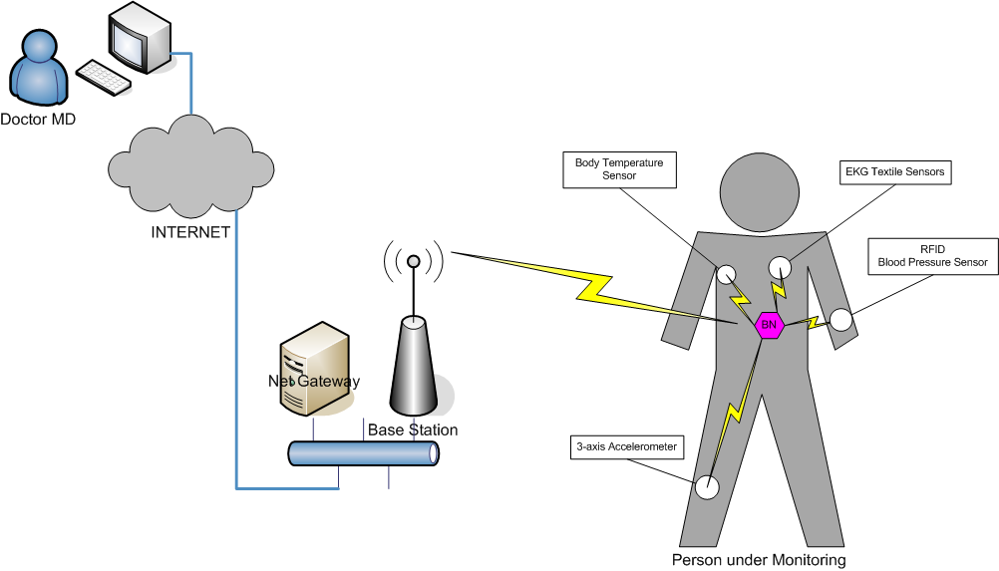

Fig.1 The integrated telemedicine platform.

The so organized distributed system includes a local powerful station that performs an initial signal processing task in order to obtain pleliminary initial results about the need for medical treatment. This phase is implemented through artificial intelligence products that are under research and development [Benton H. Calhoun, John Lach, John Stankovic, David D. Wentzloff, Kamin Whitehouse,Adam T. Barth, Jonathan K. Brown, Qiang Li, Seunghyun Oh, Nathan E. Roberts, Yanqing Zhang (Jan. 2012), D. Cantzos, D. Dimogianopoulos and D. Tseles (July 1-4, 2013), D. Cantzos, D. Dimogianopoulos and D. Tseles (2013)]. The main local system includes a communication part that can transfer data to the management information system in a central position. The operation of such a system is a top subject in this specific research domain and will definitely offer solutions that do not exist nowadays.

ΙΙΙ. Wearable Embedded Systems

Embedded Systems can be defined as devices that integrate a microcontroller or microprocessor with sensors and actuators and they are not a general purpose computer. Wearable embedded electronic systems are a special category of embedded systems that cover all applications where the system is portable and preferably is vanished under the clothes of the person who carries it. Wireless Sensor Networks (WSN) technology is proprietarily adapted for the implementation of Body Sensor Networks (BSNs). The connectivity capabilities of these embedded systems is normally based on short range wireless communication technologies creating a special category of wearable embedded systems that are forming Wireless Body Sensor Networks (WBSNs) for interconnecting various sensors and actuators in the human body. The connectivity with broadband telecommunication networks and the Internet is usually based on commercial available gateways that are using widely acceptable protocols as WiFi, Bluetooth e.t.c. This type of wearable embedded systems when combined with Internet connectivity after the Internet of Things trend will result to a new wave of applications for healthcare services, ambient assistance living for the elder and handicapped persons, vital biological signals monitoring for infants and professionals and for the training of groups of athletes and the individual in an adaptable manner.

Wearable Embedded Systems can be classified into two general categories according to the technologies used for the integrated circuits for computing and communication. In the first one, conventional chipsets are used for the microcontroller and the RF transceiver with small form factors (normally in Surface Mount Device packages) and Ultra Low Power consumption capabilities. In the second category flexible electronic technologies are utilized in combination with textiles for providing electronic textiles (e-textiles). Of course a combination can be used where yarn is modified with copper or other conductive materials for providing the power supply, as well as wired communication with a gateway carried from the individual. The more important applications of Wearable Embedded Systems are in the Fitness and Health of persons. The progress in this domain will be presented below.

- WSN- BSN technologies for implementing Wearable embedded electronic systems

The Development of a Wearable embedded electronic system using Commercial of the Shelve (COTS) available integrated circuits for measuring biological signals, is based on the evolution of microcontrollers and RF modems for Wireless Sensor Networks. The design and implementation of a wearable instrument garment capable of recording bio-chemical variables and physiological signals is the ultimate objective of a successful wearable embedded system. Such a wearable system promises to be effective for monitoring medical treatments with the continuous monitoring of human activity. The sensors of these systems can be based on innovative fibrous sensors that can be integrated in the cloths or to more advanced implantable devices.

The general architecture of a COTS-based wearable system comprises a number of BSN nodes distributed in the human body together with the sensors for the data acquisition of the appropriate biosignals. For providing advanced services that require increased processing power such a system supports telecommunication connectivity with computer networks, which may be located in the same or other remote geographical point, in order to undergo final processing. The whole system must have small physical dimensions as to not interfere with other components integrated in textiles and clothing and to be used for continuously monitoring of patients, athletes and individuals who are engaged in specific critical work (police, military, aircraft pilots, etc.). Particular attention must be given to the extremely low power consumption for extended autonomy of the system. For this reason advanced microcontrollers are normally used with Ultra low power consumption and integrated mechanisms for adaptable energy management, as well as, the implementation of modern energy-harvesting approaches.

Two variations of wireless sensor network node platforms are normally used in wearable embedded systems according to the aforementioned general architecture. One platform has low-power consumption and is the basis for the ad-hoc Body Sensor Network deployed. This portable sensor node (Fig. 2) is normally based on a low-power microcontroller and a RF-Transceiver for the acquisition of the biosignals and wireless transmission to a gateway node. In this platform presented in Fig. 3 a three-axis accelerometer and a temperature sensor are embedded.
The second platform has the role of a gateway that is the bridge between the body area network and the remote server of the medical centre or the service provider. It is usually based on a high processing power microcontroller and in many cases expert system are realized for providing services when the connectivity is difficult.

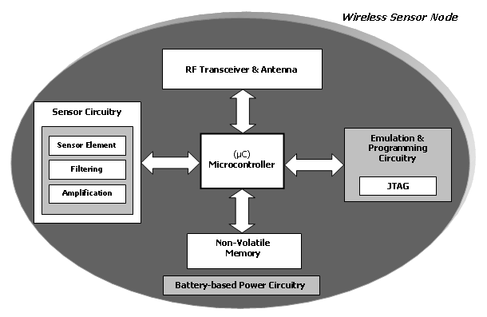
Fig. 2 Wireless Sensor Node
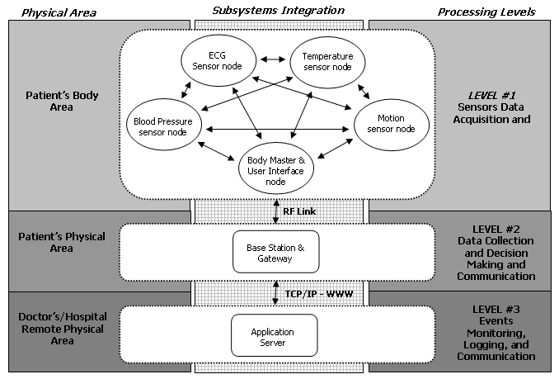
Fig. 3 Architecture of the platform for BSN

- Emergency call

There are devices that are called “emergency response systems”. For example, Southern Illinois University Carbondale (SIUC) has established a toll-free and local telephone number that one can call to receive the latest SIUC Alert [E. J. Shanko, M. G. Papoutsidakis (2013)]. This is a passive emergency information. In the event of emergency, other options, including call-centers, media alerts, and other pre-recorded messages may be available using the same toll-free number. The Wireless Medical Emergency System Gear (Wireless MESG) is a well-designed wrist cuff for the elderly or people who need help and attention. This gear consists of a medical aspect where reaching the phone or calling for help is not possible. So far, this user-friendly and low-cost gear is safe for children, adults and the elderly. It is suitable for people who have heart diseases or Alzheimer and live alone.
An emergency call scheme is considered for the system ynder development. The basic characteristics of the scheme are described below. The user-patient, by pushing the only button on the bracelet informs three relatives by text messages. The content of the message is a phrase (i.e. «SOS», «ΗELP») and the coordinates of the patient’s location are transformed into street addresses, information easy to be read by the relative in response. The main operation procedure may include many scenarios. If the button is pressed accidentally, then a buzzer is set on. The mechanism gives the ability to the user to press it again, so that the buzzer will be turned off, within 10 seconds. In the same time the central station of the system has taken the signal and a predefined procedure is starting for emergency clinical care.

- Microcontroller based Data Acquisition System

A data acquisition system has been designed and implemented [A. Karagounis, A. Tzerachoglou, D. Tseles (2013)], that enables human body physiological parameters measurements and environmental parameters as well. The system is based on Microchip PIC® 18F8720 microcontroller and includes a set of sensors such as temperature sensor, humidity sensor, pressure sensor, alcohol sensor, etc.

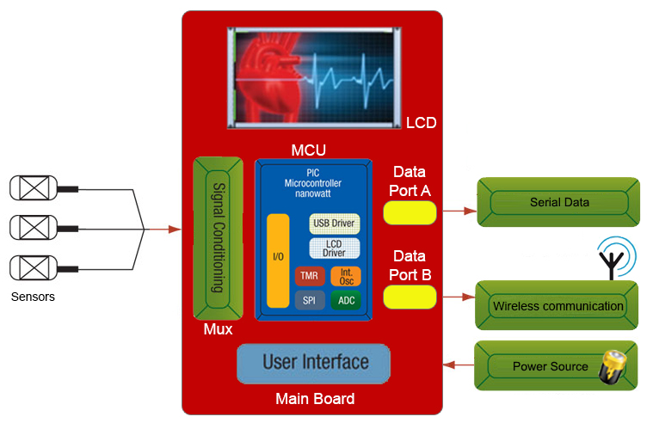

Fig. 4 Microcontroller based Data Acquisition System’s diagram

The main features of the system are:
- The system was designed to be modular having discrete units: microcontroller unit, display unit, keyboard, sensor units, etc.
- Thanks to the compact board design and the use of SMD components the system has been implemented in a single small form factor unit which is robust and easier to use (even on prototype level) plus the sensor modules which are small and functional enough.
- The unit can be easily attached on a garment or detached from it.
- The physical dimensions are ~130 L x 64 W x 9 H

The main characteristics of the design include:
- Low consumption circuitry, which enables the system to be autonomous, battery operated
- Small physical dimensions, allowing the system to be attached on a textile belt or garment
- Compact design
- More sensor inputs (due to the existence of multiplexer)
- More efficient embedded software
- Simpler, easily accessible interface
- Improved accuracy of the measurements

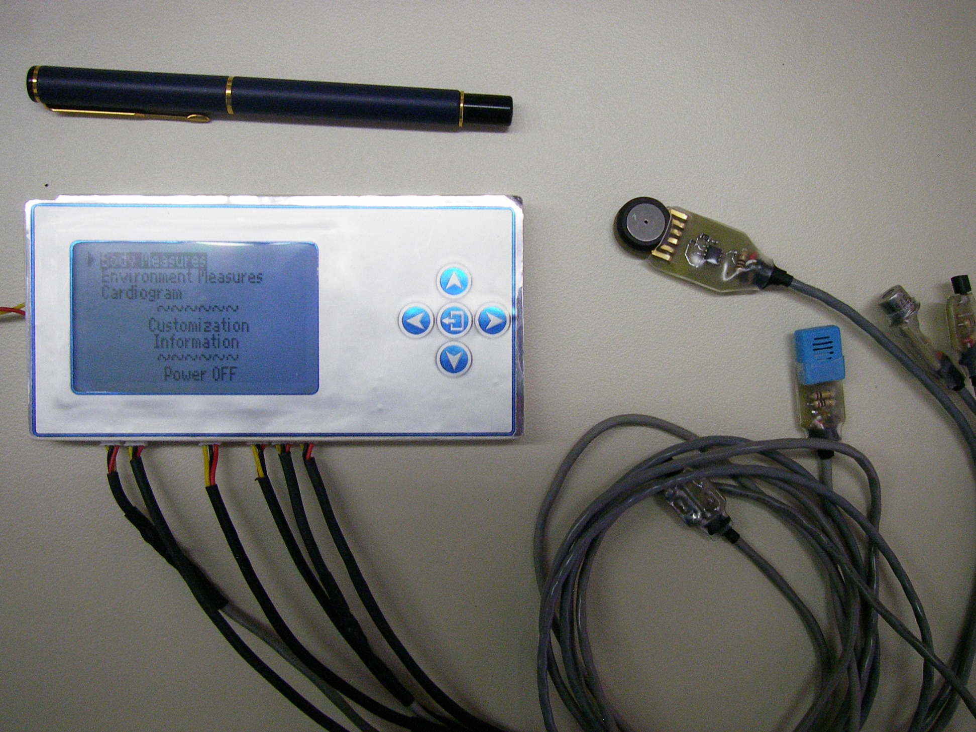

Fig. 5 The implemented Microcontroller based Data Acquisition System and the used sensors

- ECG diagnosis

A common attribute among typical ECG diagnosis schemes is their attempt to identify the underlying heartbeats in a single sweep based on standard classification techniques such as linear discriminants, neural networks and support vector machines. While these schemes may achieve high accuracy rates, they allow all ECG heartbeats to enter the classification process, regardless of their nature. In a long-term, continuous monitoring system, it would be beneficial to classify only the ECG segments that are related to arrhythmia incidents, while ignoring those segments related to a healthy heart state, especially if the latter ones form the majority of the ECG signal. Indeed, a heartbeat indicating arrhythmia or other heart related abnormality carries more significant information than a heartbeat corresponding to a healthy heart state, if the heart is assumed in a healthy state most of its lifetime. Hence, this study proposes an ECG diagnosis scheme operating on a hybrid approach, in the sense that it involves a detection and a classification stages in series.
The detection stage locates potentially abnormal arrhythmia incidents in the ECG record. Its operation is based on building an accurate model of the healthy heartbeat signal characteristics. These have been accurately modeled in relatively short ECG record segments via stochastic AutoRegressive (AR) time-series representations. Nonetheless, the fact that ECG signals are non-stationary, due to (slowly) varying mean and variance, causes the estimated AR parameters to vary across successive segments. In cases where time-series models are applied on much longer segments, the task of parameter estimation using all current ECG segment data is computationally intensive, unless recursive techniques such as Kalman filtering or Recursive AutoRegressive (RAR) modeling are used. Then, the model parameters are easily updated each time that new EGC data are available, by means of a closed-form recursive expression. In the current case, a stochastic RAR representation is chosen, because it features fewer parameters (and, thus, requires less tuning) than Kalman filters. After minimal signal preprocessing, the RAR model is identified upon healthy heart signals, aiming at accurately representing the healthy heart activity. If the heart condition changes to abnormal, the RAR model is no longer capable of describing the ECG data accurately. This manifests as changes in properties of the RAR residual signal, which may, then, be used for detecting occurrence of abnormal incidents.
The classification stage takes as input those parts of the residuals that are tied to the ECG segments, which were detected as abnormal in the first stage. Following a simple features extraction scheme, it classifies the underlying heartbeats into three different classes. These are defined in the Association for the Advancement of Medical Instrumentation ANSI/AAMI EC57: 1998 standard as Supraventricular (S), Ventricular (V) and Normal (N). Among several classification methods, the quadratic discriminants method is selected for use with the current case because it handles unbalanced training data better than support vector machines. Furthermore, it is computationally faster than both support vector machines and artificial neural network techniques, while it includes the linear discriminants method as a sub-case.
Numerous types of heartbeat incidents related to arrhythmia are reported in the literature. As far as their classification is concerned, these incident types are mapped onto specific classes, as follows:
- Class N (normal) including normal/healthy (NOR), left or right bundle branch block (LBBB or RBBB), atrial escape (AE), and nodal (junctional) escape (NE) heartbeat incidents.
- Class S (supraventricular) including atrial premature (AP), aberrated atrial premature (aAP), nodal (junctional) premature (NP), and supraventricular premature (SP) heartbeat incidents.
- Class V (ventricular) including premature ventricular contraction (PVC), and ventricular escape (VE) heartbeat incidents.
- Class F (fusion) including fusion of ventricular and normal (fVN) heartbeat incidents.
- Class Q including all heartbeat incidents, which do not fit to any of the previous classes.
In practice, several ECG diagnosis schemes incorporate class F into class V, as class F basically results from a fusion of class N and V heartbeats. On the other hand, class Q involves incidents of scarce occurrence in the data under examination. For the above reasons, the current study does not deal with classes F and Q, and only maps heartbeat incidents onto classes N, S and V. The decision to reduce the number of classes to three aims at simplifying the classification stage, without ignoring any crucial (arrhythmia-related) information.
The ECG detection stage performs an initial sweep of the considered data record aiming at detecting (but not classifying) abnormal, arrhythmia-related incidents, that is, incidents other than type NOR. The operational principle of this stage is based on classical fault diagnosis methods as used (among others) in mechanical or food engineering systems. The key idea is to build (identify) stochastic time-series models, which achieve an accurate representation of ECG signals from patients with normal (NOR) cardiac activity. In other words, we are seeking for a stochastic model, which accounts for most of the information (or dynamics) in the healthy heart state ECG signals. The residual of a modeled healthy heart signal should, in principle, exhibit zero correlation, because all useful information has been extracted. Now, if a signal involving arrhythmia incidents is processed by the previously identified stochastic model, its residual will be correlated, due to the inherent arrhythmia-related (and, thus, unaccounted for) information. Thus, detection of arrhythmia incident occurrence is achieved by examining the residual signal’s correlation as reflected on specific signal characteristics (mean, median and variance). Details on the stochastic representations used and the examination of residuals are given below.

A RAR(n_{y}, λ) model successfully identified on data from healthy heart activity and fitted to ECG data with arrhythmia-related incidents, yields residuals full of information on the incidents. This information materializes in specific trends or patterns of the residual signal at the time instant of the incident’s occurrence. An illustration is provided in Fig. 6 via an ECG record featuring five premature ventricular contraction (PVC) incidents. The multiple spikes in Fig 1(a) are called R-peaks and are typical in ECG recordings. A RAR model optimized over healthy heartbeat data produces the one-step-ahead predictions and residuals shown in Figs 6(a) and (b). The latter are correlated [Fig 6(c)], as expected, with the PVC incidents yielding spikes larger than those corresponding to R-peaks. Moreover, the distance between PVC-induced spikes and the preceding R-peaks is shorter than typical peak-to-peak intervals between successive R-peaks. Thus, occurrence of a PVC incident is detectable by assessing the residual signal’s characteristics via a set of proper rules. Such characteristics are the variance, median and mean of the signal part where the incident occurs. Setting thresholds corresponding to the usual behavior of residual signals of healthy (NOR) heartbeats, means that an abnormal incident is detected each time these thresholds are violated.
The current study considers ECG data involving aAP-, AP-, NP-, NE- and PVC-incidents. These are detected by monitoring one or more of the residual characteristics (variance, median, mean). For instance, aAP- and AP-incidents are
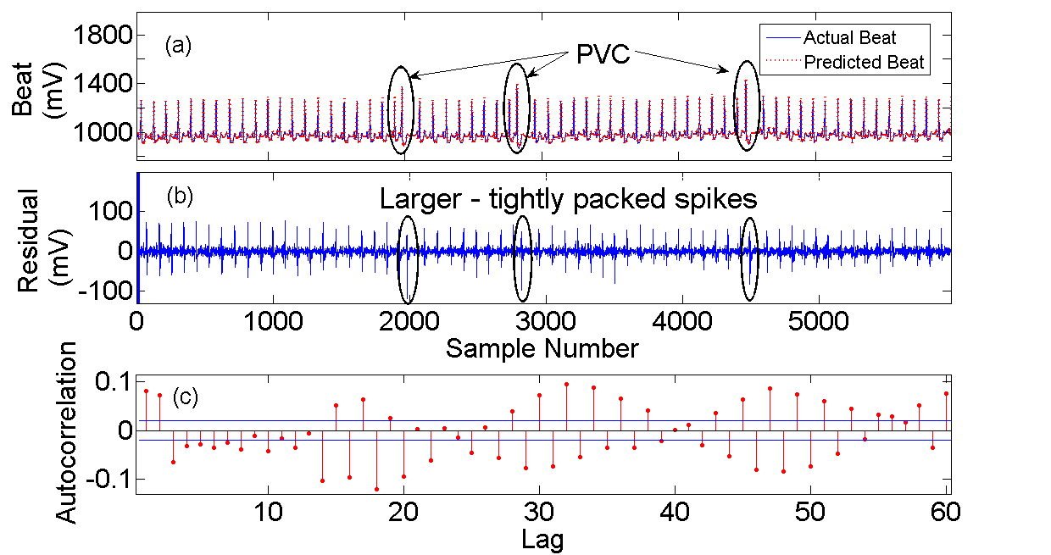
Fig. 6 An ECG record with arrhythmia incidents (PVC) evaluated via a RAR model identified on healthy ECG data: (a) Actual versus predicted beat, (b) residuals and the form of PVC-incidents and (c) residual autocorrelation plot at risk level α=0.05 indicating highly correlated residuals.

detectable by examining the variance, whereas PVC-incidents show up in both median and mean of residuals. This is not a problem, because in this first stage the scheme aims at only detecting abnormal incidents, instead of classifying them.

The previously detected abnormal time-series residuals of (1), e[k], enter the classification stage in order to assign each of the underlying heartbeats to one of three arrhythmia classes (S, V and N). Note that the N class (normal) contains, despite its name, not only healthy (NOR) heartbeats but also abnormal heartbeats such as LBBB and RBBB type. Therefore, the N class must be included for classification. Another reason for its inclusion is the very large relative number of NOR type heartbeats in a typical ECG recording, a part of which may be marked by the detection stage as abnormal and sent to the classifier. The classification stage is responsible for processing the incoming abnormal heartbeats and, if necessary, discard any falsely detected normal heartbeats. The latter heartbeats in particular are, then, classified as N class.

The detection scheme used was tested and an average of 70% of the original abnormal heart beats were detected and correctly classified.

- Conclusion

Recent advances in Electronic Sensoring Through High-tech fabrics Intelligent Systems are presented in the paper. Novel design of the electronic hardware and sophisticated software enable the development of very efficient systems for biological signals acquisition and monitoring in order to prevent health problems in patients with heart diseases and several categories of active personnel like soldiers and athletes.

Acknowledgments

The author wish to thank the members of ESTHIS team D. Cantzos, D. Dimogianopoulos, M. G, Papoutsidakis, D. Piromalis and A. Tzerachoglou for theis contribution in the progress of ESTHIS project. This research is implemented through the operational program "Education and Lifelong Learning" (ARCHIMEDES III, project MIS 383575) and is co-financed by the European Union (European Social Fund) and Greek national funds

References

- G. Priniotakis, E. Kapsalis, D. Tseles, A. Tzerachoglou, I. Chronis, D. Piromalis. (2009). ESTHIS – Wearble Electronics - Dress for Success. Proceedings of SynEnergy Forum – 1, Spetses.
- G. Priniotakis, E. Kapsalis, D. Tseles, A. Tzerachoglou, D. Piromalis (13 – 15 November 2008). Esthis: Wearable electronics. Futurotextill ’08,Kortrijk.
- D. Piromalis, D. I. Tseles, G. Priniotakis, I. Chronis, V. Kapsalis (2007). Real time monitoring of the physical and location data from parachutists soldiers. Proceedings of 2nd International Scientific Conference eRA – 2, Athens,.
- Yousef J, Lars AN (2005 Jun 22). Validation of a real-time wireless telemedicine system, using bluetooth protocol and a mobile phone, for remote monitoring patient in medical practice. Eur J Med Res. 10(6):254-62.
- P. Westbroek, G. Priniotakis, Y. Chronis, D. I. Tseles (2007). Metallization of synthetic fibres by nickel. Proceedings of 2nd International Scientific Conference eRA – 2, Athens.
- D. I. Tseles, Y. Chronis, P. Westbroek, G. Priniotakis, A. Tzerahoglou, V. Kapsalis. (2008). Development of telematics applications using smart fibers and fabrics. 04ΕΡ99, Enter Program
- Benton H. Calhoun, John Lach, John Stankovic, David D. Wentzloff, Kamin Whitehouse,Adam T. Barth, Jonathan K. Brown, Qiang Li, Seunghyun Oh, Nathan E. Roberts, Yanqing Zhang (Jan. 2012). Body Sensor Networks: A Holistic Approach from Silicon to Users. Proceedings of the IEEE, Vol. 100, No. 1.
- D. Cantzos, D. Dimogianopoulos and D. Tseles (July 1-4, 2013). ECG Diagnosis via a Sequential Recursive Time Series – Wavelet Classification Scheme. Proc. IEEE EUROCON, Zagreb, Croatia.
- D. Cantzos, D. Dimogianopoulos and D. Tseles (2013). A Hybrid Approach on ECG Diagnosis Based on Recursive Time Series Detection and Wavelet Features Classification Methods. Proceedings of International Scientific Conference eRA-8, Athens.
- E. J. Shanko, M. G. Papoutsidakis (2013). Medical Emergency Wearable System based on Wireless Tracing Gear. Proceedings of International Scientific Conference eRA-8, Athens.
- A. Karagounis, A. Tzerachoglou, D. Tseles (2013). Improved Microcontroller based Data Acquisition System for human body physiological and environmental parameters measurements. Proceedings of International Scientific Conference eRA-8, Athens.

