A novel micro-controller based data acquisition system for heart monitoring
D. Piromalis¹, A. Dagli – Kapoutsi¹, E. Chatzihristou², Ch. Dafogianni², E. Tsele, A. Charitopoulos¹, D. Tseles¹
¹PUAS, Dept. of Automation Engineering, infotech@teipir.gr
²TEI of Athens

Abstract
A novel micro-controller based data acquisition system consisted of a data acquisition board and a web server board is implemented in order to monitor heart activity and evaluation of acquired ECG data. The system may be located on clothes so forming a wearable instrument for health monitoring of patients or other categories of people.
Key words
Data acquisition systems, ECG, wearable instruments
- Introduction
Design and implementation of a wearable instrument for recording of bio- chemical variables and physiological signals has been the main objective of a research program launched some years ago (1). Personal monitoring systems may monitor heart activity and measure several critical parameters of human body (2). Effective Data Acquisition Systems have been implemented for temperature, humidity, pulse, pressure, alcohol and oxygen measurements (3) and tested under real time conditions. Special purpose sensors have been realized monitoring and a gold coated textile electrode has been implemented and studied (4). The design of an ECG module with textile electrodes and small enough in order to be wearable is the main objective in current research activity, the implementation and evaluation of such an element is described below. The diagnosis of possible cardiac abnormalities has been studied (5) and the associated software will be integrated in the system in order to enhance the capability of the Data Acquisition System in detection of abnormal conditions and prevention of failures in heart activity.
Τhe ECG is a widely-studied biosignal and describes the electrical activity of the heart. The ECG consists of QRS-complex, P-wave and T-wave. The continuous monitoring of ECG is the most widely-used technique for cardiorespiratory monitoring in the NICU (6).
The ECG is measured through gel electrodes attached on the body, but the long-term use of gel electrodes may cause skin irritation and allergic contact reactions. Because of the possible skin damage and wire disturbance in infants mainly, several techniques were developed in order to avoid the use of traditional gel electrodes in the ECG measurement of infants and adults who need a long term monitoring.
The development of textile electrodes, including advances in conductive fabrics, metal-coated textiles and flexible electronics, makes biosignal measurements more effective and human-friendly. Some researchers use metal (such as silver)-coated polyurethane fabrics (one of the best textile materials for ECG measurement) to develop textile electrodes (7,8,9,10)
One kind of silver textile electrode integrated with a smart jacket has a knitted structure and can be mounted in different positions in the jacket to achieve good measurement results (7,11).

- The novel data acquisition system

In continuation to previous approaches and implementations (3), a novel improved data acquisition system has been implemented to monitor and record human heart activity. The system can take measurements and may give an Electrocardiogram (ECG) figure after dedicated processes. The whole system is based on the Texas Instruments ADS1292 multichannel, simultaneous sampling, 24-bit, deltasigma (ΔΣ) analog-to-digital converters (ADCs) with a built-in programmable gain amplifier (PGA), internal reference, and an onboard oscillator (Fig. 1). The low power consumption and reduced size enables the creation of scalable medical instrumentation systems at significantly reduced size and overall cost.

Communication to the device may be realized through SPI and the ADS1x9xECG-FE evaluation board (Fig. 2) that provides a USB interface for PC application connectivity requiring a mini USB to USB cable. The features of the parts are described in associated manuals (Texas Instruments, 2012).

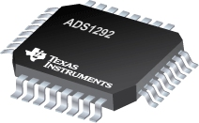
Figure 1: Texas Instruments ADS1292
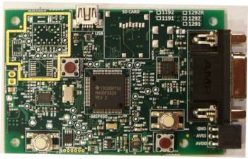
Figure 2: ADS1292ECG-FE

Power for the board is derived either from the USB or from a separate battery input. The ADS1x9x includes an on-chip circuit that generates 512 kHz clock and an 8 GB Flash memory has been installed for data storage.
The installed micro-controller receives the data from the ADC through the SPI interface an sends them to the PC. The software is designed to handle the following activities:
- Data acquisition.
- ADC Lead off detection.
- DC signal removal.
- Multi band pass filtering.
- ECG lead formation.
- QRS (HR) detection.
- RR Detection.
- USB communication.
- Firmware upgrade through USB.

In the Fig. 3 the firmware architecture is shown and in the Fir.4 the data flow in the system is described. A 1st order IRR filter is used to remove the DC component from the acquired data. The transfer function of the used filter is:
$H\left(z\right)=\frac{Y(z)}{X(z)}=\frac{1-z^{-1}}{1-{az}^{-1}}$ (1)
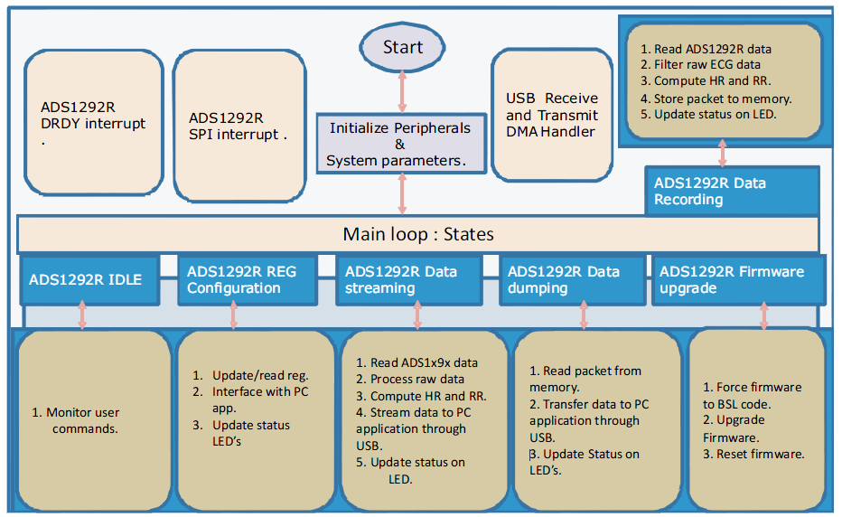
Figure 3: Firmware Architecture
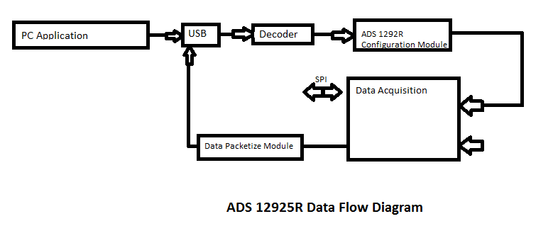
Figure 4: Data flow Diagram
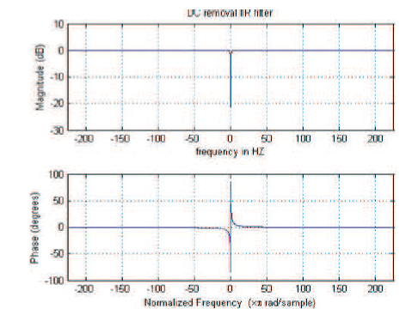
Figure 5: IRR filter frequency response

Then a Multiband-pass filter is used to remove unwanted signals and power noise from the live data. The frequency response of this filter is shown in Fig.6.

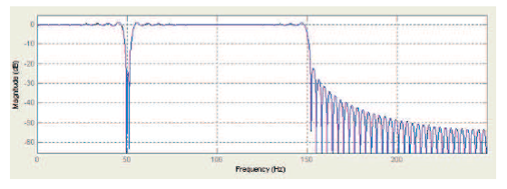
Figure 6: MBF frequency response
And final a Band Pass filter provides a sharp cut-off at 40 Hz with attenuation of 30dB at the stop band.(Fig.7)
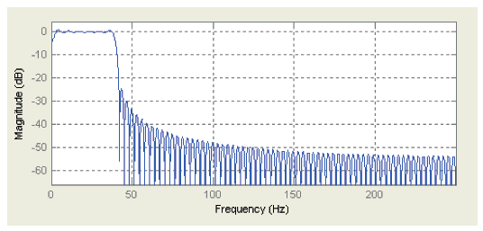
Figure 7: Band Pass filter frequency response

Most dry-contact and non-contact electrodes used in ECG measurements carry large capacitive elements across the skin-electrode path thus making lead-off detection challenging. Newer system designs shift to favor ac lead-off methods that focus on monitoring the magnitude of an excitation signal frequency to determine lead status. Analog filtering and post-processing techniques of ADC results are used to analyze the signal.

The ADS 1292 family incorporates the circuitry needed to perform either DC or AC lead-off without the need of external components.

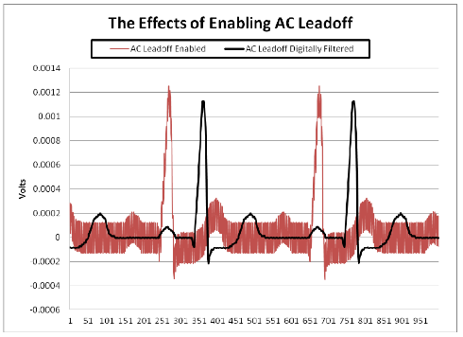
Figure 8: AC lead-off example - *Signals plotted out of phase

- The system Software

The used software is a LabVIEW program that establishes connection to the board through the USB port. It provides the user with a multitude of features and it consists of 4 main tabs.
- ADC registers Tab (Fig. 9a)
The ADC registers Tab allows the user to configure various registers of the ADS1x9x.
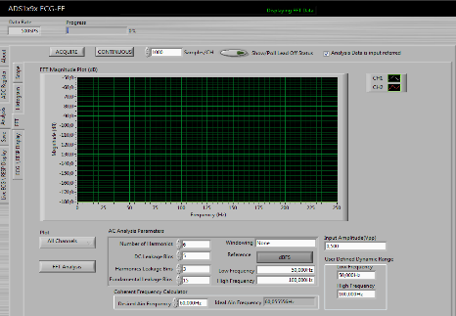
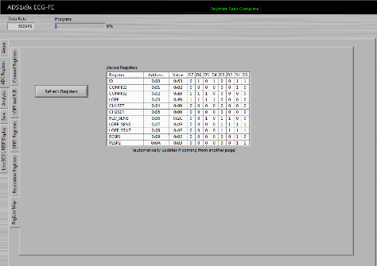

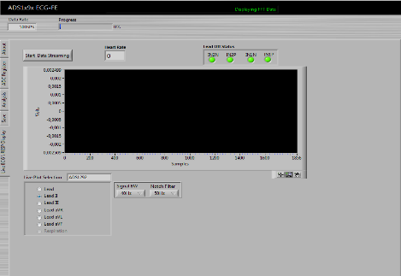
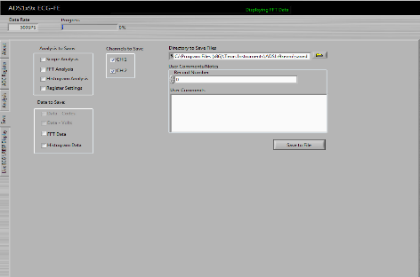
- (b)

(c) (d)
Figure 9: (a) Registers Tab, (b) Analysis Tab – FFT, (c) Save Tab,
(d) ECG / RESP display Tab

- Analysis Tab (Fig. 9b)
The Analysis Tab consists of the following sub-tabs
Scope
Histogram
FFT
ECG / RESP display
The analysis tab also offers various routines for visualizing the raw data and performing filtering.
- Save Tab (Fig. 9c)
The Save Tab provides the user options for choosing the file location and the name of the file that contains the data he wants to save for future analysis.
- Live ECG / RESP display Tab (Fig.9d)
In this Tab real-time ECG and Respiration data are shown. This tab also shows heart rate, respiration rate and lead-off information.

- The System operation in Comparison with a traditional System

In order to evaluate our system’s data, an experiment was performed. Four healthy adult individuals took an ECG at the hospital with a traditional well established Electro-cardiograph and the ADS1x9xECG-FE module. While conducting the measurements the same leads were used for both systems. A sample of this procedure is shown below. The output of a traditional Electrocardiograph is shown in Fig.10.
The recording of dynamic electrocardiogram (ECG / EKG) from various body points is reflected the conventional cardiograph in healthy subjects and similar digital mapping in the same healthy subjects in the same period. In surveying both the conventional and the digital analyzer EKG (ECG) is illustrative of the physiological characteristics of the ECG: the wave (wave) P, the complex (QRS) and wave (wave) T. The output of the system for the same person is shown in Fig.11 before filtering and in Fig.12 the output after filtering is shown.
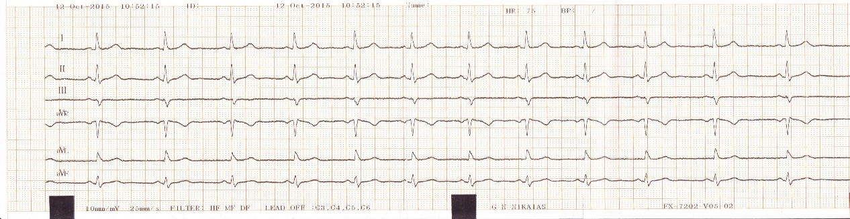
Figure 10: Subject - Hospital ECG
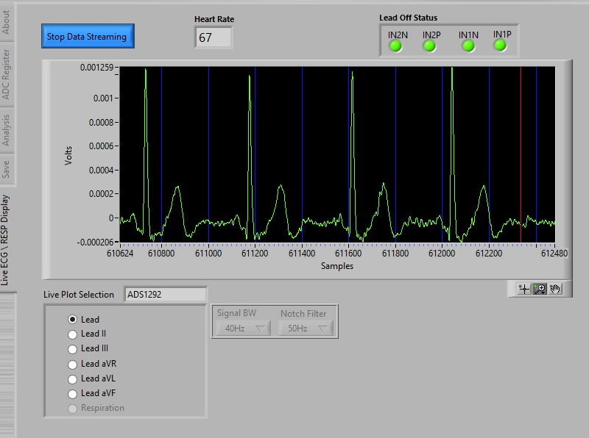
Figure 11: Subject - ADS1x9xECG (raw)
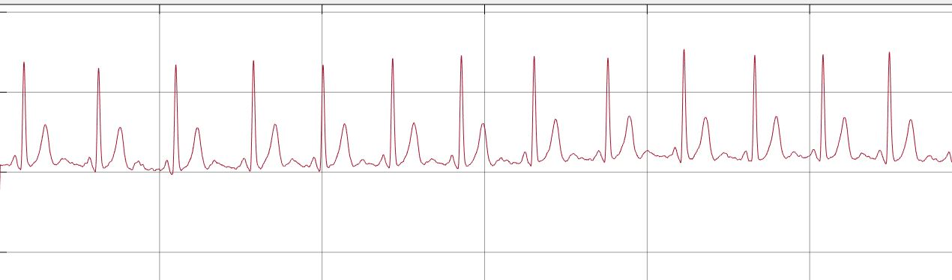
Figure 12: Subject - ADS1x9xECG (After filtering)
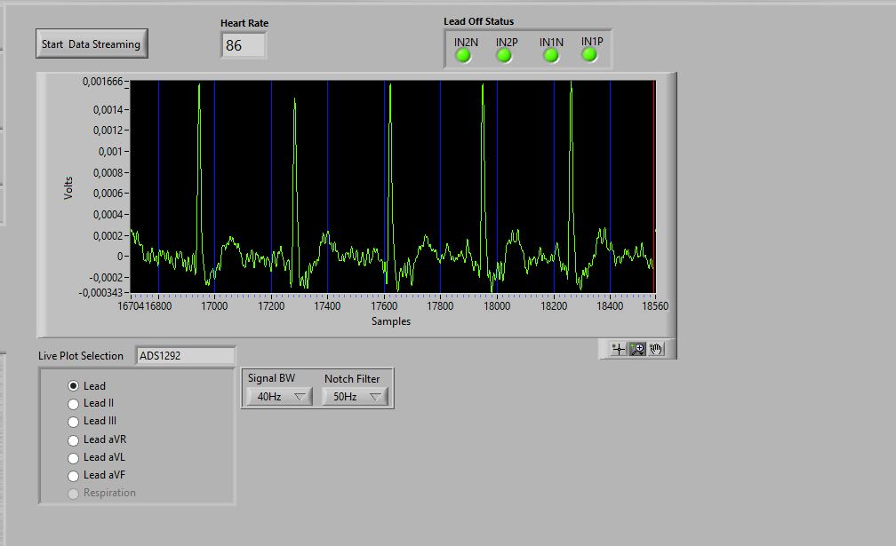
Figure 13: Subject - ADS1x9xECG (with wearable textile electrodes)

In our study the wearable textile electrodes recorded the ECG of a patient Comparing the leads of the ECG with the usual method Fig. 10 and the ECG from the textile electrodes fig 13, we can conclude that: The heart rate, the rhythm and the scheme of QRS cardiac waves, can be well detected and are clearly visible after the filtering. The ECG recorded with a textile sensor in a patient can help him to seek help urgently, with an alarm system, which can send alarm information to clinicians or family members through wireless device (such as mobile phones and Bluetooth) whenever the patient meets an emergency. It is noteworthy that the false alarm may disturb clinicians and others, therefore the optical algorithms and the level of sensitivity of sensors should be taken into count.With specialized sensors and integrated sensing systems, wearable sensor systems can easily monitor the vital signs or physical parameters of an individual healthy or sick. In order to realize the wide application of this technology in our life some detailed technical matters still need to be improoved as the noise of the movements of the individual,the protection of reliability of the the wearable sensors , which may be affected by many external influences ,etc and the optimal choice of analytical algorithms for data in different applications.

5. Evaluation of Results
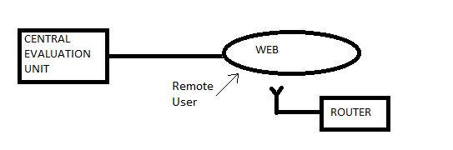
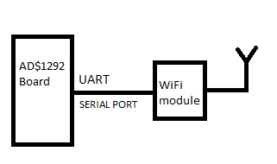
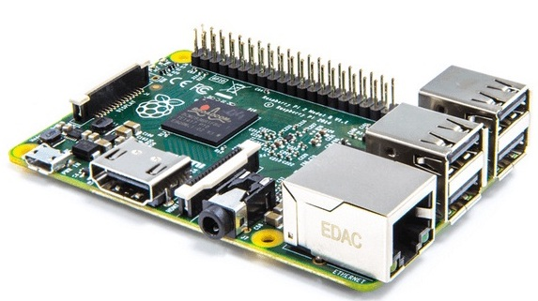
Figure 14: The Raspberry Unit and the communication scheme
The display and evaluation of the measurements may be executed in a local station (Raspberry Pi) or in a central evaluation unit (Fig. 14). The Raspberry Pi is a web server i.e. a computer with dimensions of a credit card, that may be connected directly to a display (computer or TV) and using a keyboard and/or a mouse we can program its operation. The operating system of the Raspberry is a Linux version (Rasbian). The data may be stored in the Raspberry is memory or may be transmitted to a central evaluation unit through web.
- Conclusion
New technology equipment can integrate even more functions in even more effective kits in order to perform traditional activities like ECG acquisition and evaluation. The proposed configuration takes ElectroCardioGrams that may be stored locally in a web server or transmitted to a central evaluation unit. This ensures instant detection of malfunctions locally or through remote users.
Acknowledgements
This research is implemented through Archimedes III, Operational Program "Education and Lifelong Learning" and is co-financed by the European Union (European Social Fund) and Greek national funds.
The authors would like to thank very much the post-graduate student K. Effraimidis for very efficient efforts in implementation of the micro-controller based data-acquisition system and the measurements acquisition and presentation.

REFERENCES
Articles
- D. I. Tseles, ESTHIS (Electronic Sensoring Through High-tech Fabrics Intelligent Systems), International Scientific Conference eRA-6, Piraeus, 2011.
- E. J. Shanko, M. G. Papoutsidakis, Medical Emergency Wearable System based on Wireless Tracing Gear, International Scientific Conference eRA-8, Piraeus, 2014.
- Ch. Drosos, A. Dagli – Kapoutsi, D. Piromalis, D. Tseles, Improved Microcontroller based Data Acquisition System for human body physiological and environmental parameters measurement, International Scientific Conference eRA-9, Piraeus, 2014.
- G. Priniotakis, A. Tzerachoglou, P. Yannakopoulos, P. Kervalishtili, D. Tseles, Study on geometrical behaviour of the conductivity of gold coated textiles, International Scientific Conference eRA-10, Piraeus, 2015.
- D. Cantzos, D. Dimogianopoulos and D. Tseles, A Hybrid Approach on ECG Diagnosis Based on Recursive Time Series Detection and Wavelet Features Classification Methods, International Scientific Conference eRA-8, Piraeus, 2013.
- Chen, W.; Oetomo, S.B.; Feijs, L.; Bouwstra, S.; Ayoola, I.; Dols, S. Design of an integrated sensor platform for vital sign monitoring of newborn infants at neonatal intensive care units.J. Healthcare Eng. 2010, 1, 535–554.
- Pola, T.; Vanhala, J. Textile electrodes in ECG measurement. In Proceedings of the 2007 3rd International Conference on Intelligent Sensors, Sensor Networks and Information, Melbourne,QLD, Australia, 3–6 December 2007; pp. 635–639.
- Linti, C.; Horter, H.; Österreicher, P.; Planck, H. Sensory baby vest for the monitoring of infants.In Proceedings of the International Workshop on Wearable and Implantable Body Sensor Networks (BSN’06), Cambridge, MA, USA, 3–5 April 2006; pp. 3–137.
- Chen, W.; Dols, S.; Oetomo, S.B.; Feijs, L. Monitoring body temperature of newborn infants at neonatal intensive care units using wearable Sensors. In Proceedings of the Fifth International Conference on Body Area Networks, Corfu Island, Greece, 10–12 September 2010; pp. 188–194.
- Bouwstra, S.; Chen, W.; Feijs, L.; Oetomo, S.B. Smart jacket design for neonatal monitoring with wearable sensors. IEEE Body Sens. Netw. 2009, 40, 162–167.
- G. Priniotakis, E. Kapsalis, D. Tseles, A. Tzerachoglou, I. Chronis, D. Piromalis, Esthis – Wearable Electronics – Dress for Success, SynEnergy Forum (S.E.F.)-1, Spetses, 28-31 May 2008

Manuals
- Texas Instruments, Understanding Lead-Off Detection in ECG (May 2012 – Revised January 2015)
- Texas Instruments, ADS1291 ADS1292 ADS1292R – Low-power, 2channel, 24-bit Analog front End for biopotential measurements (December 2011 – Revised September 2012)
- Texas Instruments ADS1x9xECG-FE User’s Guide ( December 2011 – Revised April 2012)

