DC Motor Drive Applying Conventional and Fuzzy Based PI Control Techniques
George Ch. Ioannidis, Stavros D. Kaminaris, Constantinos S. Psomopoulos, Spiros Tsiolis, Pavlos Pachos, Iraklis Villiotis, Pantelis Malatestas
Department of Electrical Engineering, Piraeus University of Applied Sciences, Egaleo, Greece

Abstract
In this paper, a separately excited DC motor applying conventional PI and Fuzzy PI controller is presented. In the first, conventional PI controller, the proportional and integral gains (K_{p}, K_{i}) are estimated using a fine-tuning procedure incorporated in Matlab software while in the second one, these gains are adjusted according to Fuzzy Logic. There are 25 fuzzy rules for self-tuning of each parameter of PI controller. The Fuzzy Logic Controller has two inputs. One is the motor speed error between the reference and actual speed and the second is the change in speed error (speed error derivative). Then, the outputs of the FLC namely, the parameters of the PI controller are used to control the speed of the DC Motor. The fuzzy self-tuning approach implemented on a conventional PI structure was able to improve the dynamic as well as the static response of the system. Comparison between the conventional output and the fuzzy self-tuning output was done on the basis of the simulation result obtained by Matlab/Simulink environment. The simulation results demonstrate that the designed fuzzy self-tuned PI controller realize a good dynamic behavior of the DC motor, a perfect speed tracking with less rise and settling time, minimum overshoot, minimum steady state error and present improved performance compared to conventional PI controller.
Keywords: DC motor drive, speed control, modeling DC motors, PI control, Fuzzy PI control

Introduction
DC motors are still used in several applications such as industrial production and processing of paper pulp, textile industries and public transportation (Ioannidis, et al., 2012).
The development of high performance motor drives is very important in industrial applications in order firstly to reduce the consumed electric energy and secondly to effectively control the speed and torque of these systems limiting the vibrations on the motors' axis and consequently their mechanical stress (Bansal and Narvey, 2013).
Generally, a high performance motor drive system must have good dynamic speed command tracking and load regulating response to perform tasks. Controllers which are conceived to control the speed of DC motors execute a variety of tasks and they could be conventional and numeric controllers like: proportional integral (PI), proportional integral derivative (PID), Fuzzy Logic Controller (FLC) or the combination of them (Alloua, Gasbaoui and Abderrahamani, 2009). Each one of them has its own advantages and disadvantages depending on the application they are used (Natsheh & Buragga, 2010).
Lotfi Zadeh, the father of fuzzy logic, claimed that many sets in the world that surrounds us are defined by a nondistinct boundary. Zadeh decided to extend two-valued logic, defined by the binary pair {0, 1}, to the whole continuous interval [0, 1], thereby introducing a gradual transition from falsehood to truth (Natsheh & Buragga, 2010).
Fuzzy logic is a method of rule-based decision making and process control that emulates the thought process used by human experts. It differs from traditional Boolean (or two-valued) set theory in that, partial membership in a set is allowed. Traditional Boolean set theory is two-valued in the sense that a member belongs to a set or does not and is represented by 1 or 0, respectively. Fuzzy set theory allows for partial membership or a degree of membership, which might be any value along the continuum of 0 to 1. A linguistic term can be defined quantitatively by a type of fuzzy set known as a membership function, which specifically defines degrees of membership based on a property. With membership functions defined for controller, the formulation of a rule base of IF-THEN type conditional rules is done. Such a rule base and the corresponding membership functions are employed to analyze controller inputs and determine controller outputs by the process of fuzzy logic inference. By defining such a fuzzy controller, process control can be implemented quickly and easily. A comprehensive review of the classical design and implementation of the fuzzy logic controller can be found in the literature (Lee, 1990a; Lee, 1990b; Jantzen, 1998; Isermann, 1998). A fuzzy IF-THEN rule-based system consists of the following modules (Yager and Filev, 1994):
- Fuzzification: Converting crisp facts into fuzzy sets described by linguistic expressions. Membership functions can be flat on the top, piece-wise linear and triangle shaped, rectangular, or ramps with horizontal shoulders.
- Inference: The fuzzy IF-THEN rule expresses a fuzzy implication relation between the fuzzy sets of the premise and the fuzzy sets of the conclusion.
- Aggregation: This process aggregates the individual rule outputs to obtain the overall system output. It will be also a fuzzy subset over the output universe (a union operation yields a global fuzzy set of the output).
- Defuzzification to obtain crisp output (various defuzzification methods can be used, as, e.g., center of gravity, bisector of area, and mean of maximum, to obtain a crisp numerical output value).
In this paper, conventional PI and fuzzy based PI controllers are presented in order to highlight their basic characteristics and applications for DC motor drives. More specifically, a separately excited DC motor is taken as a case study and the control is achieved using conventional PI and intelligent fuzzy logic based PI controller. The efficiency is improved by controlling the speed with fuzzy logic PI controller and results are presented graphically.

DC Motor Model
DC motors exhibit wide speed range, good speed regulation, starting and accelerating torques in excess of 400% of rated, less complex control and usually less expensive drive. The equivalent circuit of a separately excited DC motor, which is often used for velocity tuning and position adjustment using the armature voltage control method, is shown in Fig.1a.
Figure 1. a) Equivalent circuit of the DC motor b) Simulink DC motor model.
where R_{a}, L_{a}, I_{a}, V_{a}, E_{b}, T_{m}, w_{m}, J_{m}, B_{m}, K_{b} and K_{T} are the armature resistance (Ω), armature inductance (H), armature current (A), input voltage (V), back electromotive force (emf) (V), motor torque (Nm), angular velocity of rotor (rad/s), rotor inertia (kgm), friction constant (Nms/rad), emf constant (Vs/rad) and torque constant (Nm/A) respectively.
In Fig. 1b, the DC motor model built in Simulink is shown. The motor model is converted to a subsystem with armature voltage (V_{a}) and load torque (T_{load}) as inputs, and angular speed in (w_{m}), armature current (I_{a}) and torque load (T_{m}) as outputs. The basic equations governing the operation of the DC motor is shown below:
A 0.75kW, 220V, 2000rpm separately exited DC motor with the parameters shown below, was used in Simulink simulations.
R_{a} = 7.56 Ω J_{m} = 0.02215 kgm K_{b} = 0.98 Vs/rad
L_{a} = 0.029 H B_{m} = 0.00295 Nms/rad K_{T} = 0.98 Nm/A

DC Motor Drive
DC motor drives are available for many years now as controlled rectifier-fed (thyristor-fed) DC drives and chopper-fed DC drives (Ioannidis, et al., 2013). Choppers are now being used all over the world for rapid transit systems. They are also used in trolley cars, marine hoist, forklift trucks and mine haulers. Chopper systems are characterized by high efficiency, fast response and regeneration operation capability (Ioannidis, et al., 2013).
A single-switch chopper using a Thyristor, BJT, MOSFET or IGBT is presented in Fig. 2. This chopper is a 1-quadrant hard switching dc to dc converter which means that it can supply only positive voltage and current to a DC motor. A DC motor drive based on this converter is being used in this paper due to its simplicity.
Figure 2. 1-quadrant hard switching DC motor drive.

Conventional PI Controller
A proportional–integral controller (PI controller) is widely used in industrial control systems (see Fig.3). It is a generic control loop feedback mechanism and used as feedback controller. PI working principle is based on the calculation of the error value from the processed measured value and the desired reference point. The work of controller is to minimize the error by changing the inputs of the system. If the system is not clearly known, best results are achieved applying PI controller provided it is tuned properly by keeping parameters of the system according to the nature of system (Ashraf, 2010).
Figure 3. A block diagram of a PI controller in a feedback loop.
The PI measurement depends upon two parameters which are called the proportional (P) and the integral (I) part:
- P determines the reaction to current error,
- I determines reaction to the sum of recently appeared errors,
The sum of these two parts contributes to the control mechanism such as speed control of a motor in which P value depends upon current error and I on the accumulation of previous error. The P term takes the output to proportional of error value. Its response can be adjusted by multiplying the error by a constant K_{p} which is called proportional gain. If proportional gain is large then it creates a high overshoot which unstables the system, while a small output change makes a small control action.The integral term contributes to both error and duration of error proportionally. Error sum gives offset that corrected previously. The calculated error is multiplied by the integral gain and then added to the controller output. It finally reduces the steady state error.
There are many methods of PI tuning like: Ziegler–Nichols, Cohen–Coon, manual tuning and software tools. Some important advantages of PI control technique are that it is easy and simple to implement and easy to understand.
In this paper, a PI controller is designed following an optimization procedure provided by Matlab and specifically by Simulink Control Design software. The PI tuner automatically computes a linear model of the plant and keeps tuning the PI gains to achieve a good balance between performance and robustness. According to the PI tuning procedure the typical objectives are:
- Closed-loop stability — the closed-loop system output remains bounded for bounded input.
- Adequate performance — the closed-loop system tracks reference changes and suppresses disturbances as rapidly as possible. The larger the loop bandwidth (the frequency of unity open-loop gain), the faster the controller responds to changes in the reference or disturbances in the loop.
- Adequate robustness — the loop design has enough gain margin and phase margin to allow for modeling errors or variations in system dynamics.
Using the above procedure, the proportional and integral gains K_{p} and K_{i} are estimated in our case and shown below:
K_{p} = 1.439 x 10⁻⁴ and K_{i} = 3.512 x 10⁻³
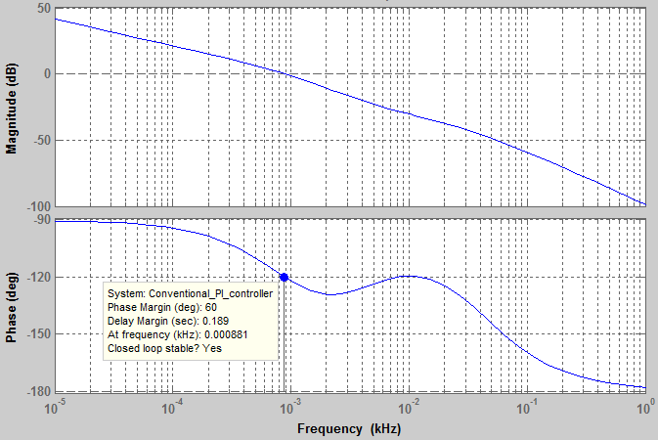
Figure 4. Loop gain Bode diagrams for the case of conventional PI controller.
The Loop gain Bode diagrams of the DC motor using the conventional PI controller are presented in Fig.4. As it can be seen , the gain margin is infinite while the phase margin is set to 60º ensuring a good balance between performance and robustnness.

Fuzzy PI Controller
The inputs to the Self-tuning Fuzzy Controller are speed error "e(t)" and Change-in-speed error "de(t)". The inputs shown in figure are described by:
Using fuzzy control rules on-line, PI parameters “K_{p}" and “K_{i}" are adjusted, which constitute a self-tuning fuzzy PI controller as shown in Fig. 5.
PI parameters fuzzy self-tuning is to find the fuzzy relationship between the two parameters of PI "e" and "de", and according to the principle of fuzzy control, to modify the two parameters in order to meet different requirements for control parameters when "e" and "de" are different, and to make good dynamic and static performance as the control object.
Figure 5. The structure of self-tuning PI controller.

Fuzzy Linguistic Terms for Input and Output Variables
The Fuzzy Linguistic Terms used for Input ("e" and "de") and Output Variables (“K_{p}" and “K_{i}") are defined in Table 2.

Table 2. Fuzzy linguistic terms used for input and output variables.
Term | NL | NS | ZE | PS | PL
Definition | Negative Large | Negative Small | Zero | Positive Small | Positive Large

Fuzzy Membership Functions for Input and Output Variables
Fuzzy membership functions are used as tools to convert crisp values to linguistic terms. A fuzzy membership function can contain several fuzzy sets depending on how many linguistic terms are used. Each fuzzy set represents one linguistic term. In this paper, five fuzzy sets are obtained by applying the five linguistic terms. The number for indicating how much a crisp value can be a member in each fuzzy set is called a degree of membership .One crisp value can be converted to be “partly” in many fuzzy sets, but the membership degree in each fuzzy set may be different. In order to define fuzzy membership function, designers can choose different shapes based on their preference or experience. The popular shape is triangular because this shape is easy to represent designer’s idea and require low computations time. In order to improve the performance of FLC, the rules and membership functions are adjusted. The membership functions are adjusted by making the area of membership functions near ZE region narrower to produce finer control resolution. On the other hand, making the area far from ZE region wider gives faster control response. Also the performance can be improved by changing the severity of rules. The membership functions used in this paper for speed error (e) and change in speed error (de) are defined in Fig. 6.
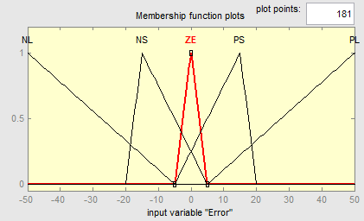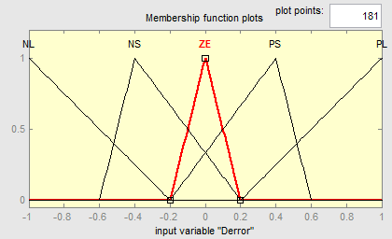
a) b)
Figure 6. Membership functions for a) input variable “e” and b) input variable “de”.
The membership functions used in this paper for “Kp” and “Ki” are defined in Fig. 7.
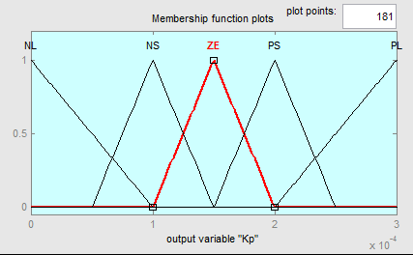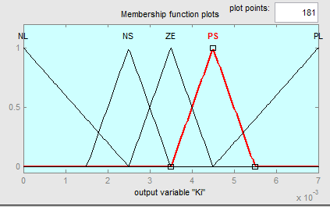
Figure 7. Membership functions for a) output variable “K_{p}” b) output variable “K_{i}”.

Rule Base
The rules are in the form of IF-THEN statements.For example, IF the error(e) is equal to negative low (NL) and change in error is negative low (NL) Then the change in speed is positive small (PS). The solutions are based on experiences of a designer or the previous knowledge of the system.The efficiency can be improved by adjusting the membership functions and rules. Tables 3 and 4 show the rule base for K_{p} and K_{i}. There are 25 rules in total combining all the rules presented in Tables 3 and 4.
Table 3. Fuzzy rule table for K_{p} | Table 4. Fuzzy rule table for K_{i}.
  e \ de | NL | NS | ZE | PS | PL
  NL | PL | PL | PS | PS | ZE
  NS | PL | PS | PS | ZE | NS
  ZE | PL | PS | ZE | NS | NL
  PS | PS | ZE | NS | NS | NL
  PL | ZE | NS | NS | NL | NL
  e \ de | NL | NS | ZE | PS | PL
  NL | NL | NL | NS | NS | ZE
  NS | NL | NS | NS | ZE | PS
  ZE | NL | NS | ZE | PS | PL
  PS | NS | ZE | PS | PS | PL
  PL | ZE | PS | PS | PL | PL
The Loop gain Bode diagrams of the DC motor using the fuzzy based PI controller are presented in Fig.8. As it can be seen, the gain and phase margins are about 92db and 61º ensuring again a good balance between performance and robustnness.
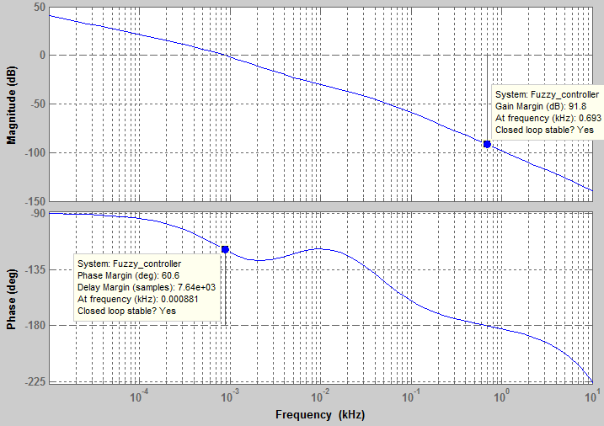
Figure 8. Loop gain Bode diagrams for the case of fuzzy based PI controller.

Simulation Results
In this section, SIMULINK models for both conventional PI and fuzzy PI controllers for the selected DC motor drive are presented. Simulation results for start up, load and speed step changes are also presented and discussed. Particularly, the following cases have been simulated:
i) Motor startup at 25% and 75% of rated load
ii) Motor load step change from 25% to 75% and 0% to 100% of rated load at 0.5s
iii) Motor speed step change from 1000rpm to 1200rmp at 25% and 75% of rated load at 0.5s
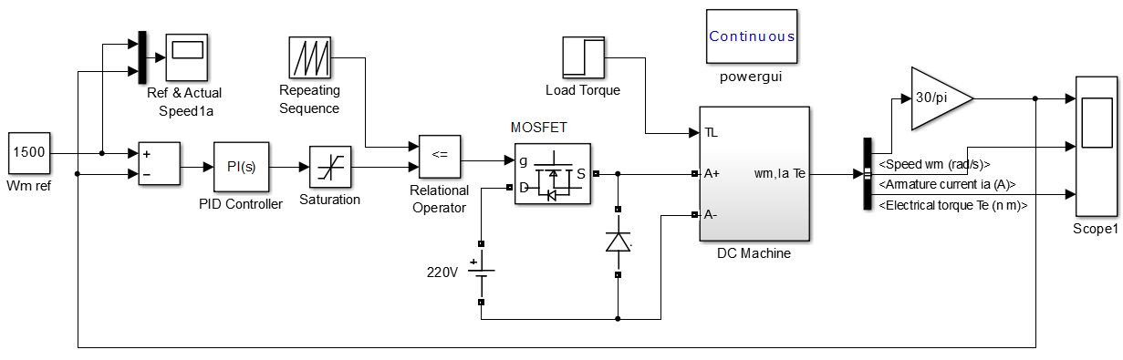
Figure 9. SIMULINK model of the DC motor drive utilizing conventional PI control.
a) | 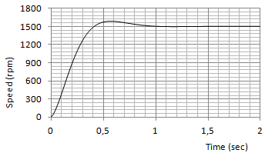  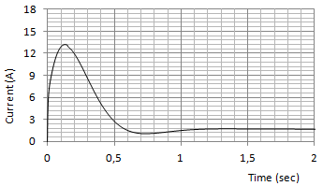 | b) | 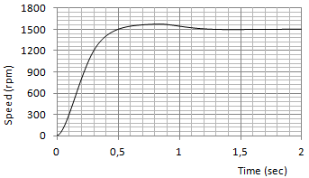  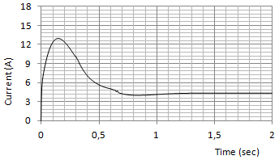
Figure 10. Startup response of the DC motor drive utilizing conventional PI control.
Speed (rpm) and current (A) at a) 25% of rated load and b) 100% of rated load.
a) | 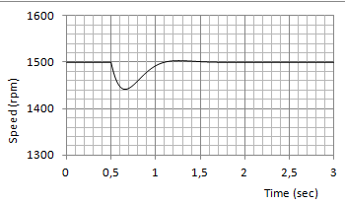  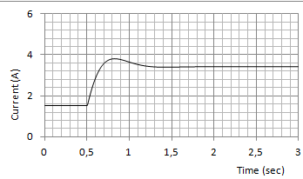 | b) | 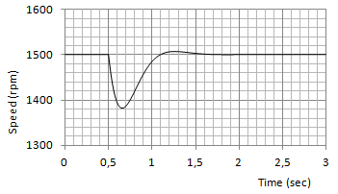  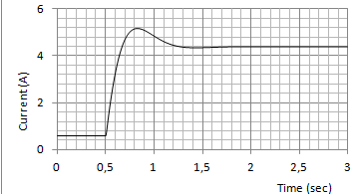
Figure 11. Load step change response of the DC motor drive utilizing conventional PI control.
Speed (rpm) and current (A) during motor load step change from a) 25% to 75% of rated load and b) 0% to 100% of rated load, at 0.5s in both cases.
a) | 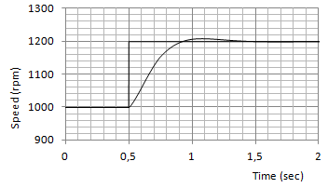  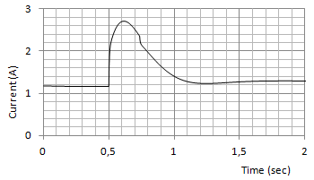 | b) | 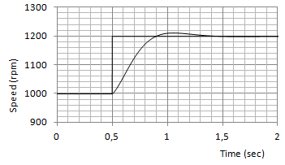  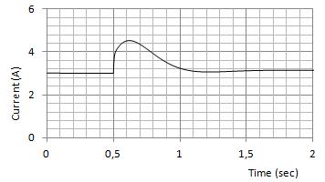
Figure 12. Speed step change response of the DC motor drive utilizing conventional PI control.
Speed (rpm) and current (A) during motor speed step change from 1000rpm to 1200rpm for a) 25% of rated load and b) 75% of rated load, at 0.5s in both cases.

Conventional PI Controller
The SIMULINK model of the DC motor drive utilizing conventional PI control is presented in Fig.9. In Figs.10, 11 and 12 the simulation results (speed and armature current) for startup, load and speed step changes for the DC motor drive utilizing conventional PI control are presented.

Fuzzy PI Controller
The SIMULINK model of the DC motor drive utilizing fuzzy PI control is presented in Fig.13. In Figs.14, 15 and 16, the simulation results for startup, load and speed step changes for the DC motor drive utilizing fuzzy PI control are shown.
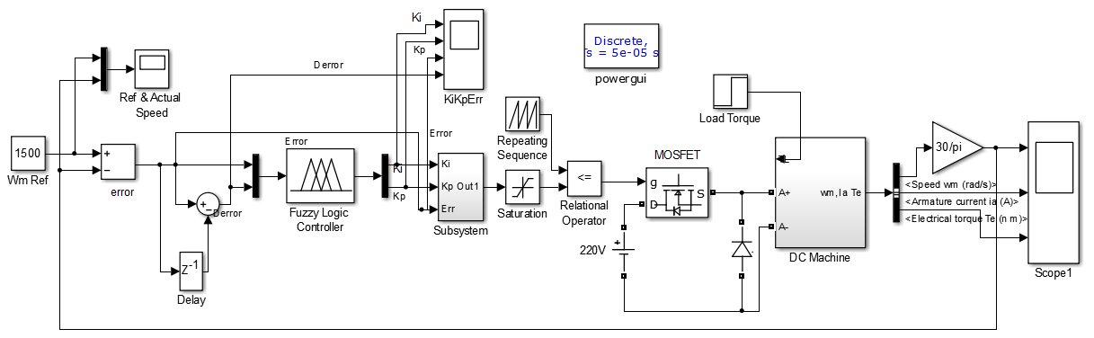
Figure 13. SIMULINK model of the DC motor drive utilizing fuzzy PI control.
The simulation results clearly indicate the superior of fuzzy control. It is well seen in the case of sudden change due to load torque disturbances or speed reference changes because it is inherently adaptive in nature.

a) | 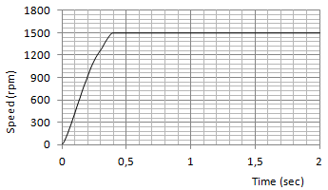  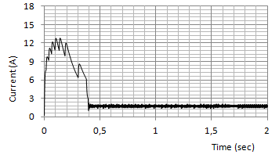 | b) | 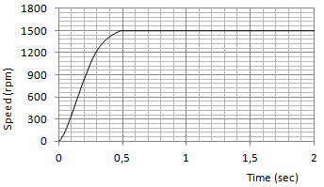  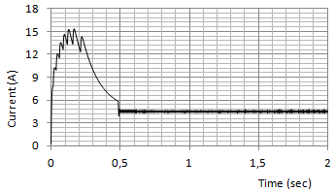
Figure 14. Startup response for the DC motor drive utilizing fuzzy based PI control.
Speed (rpm) and current (A) during motor startup at a) 25% of rated load and b) 100% of rated load.
a) | 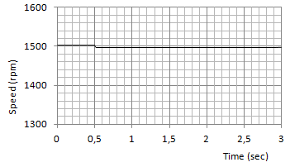  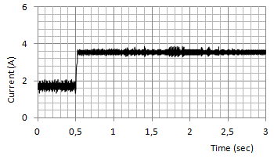 | b) | 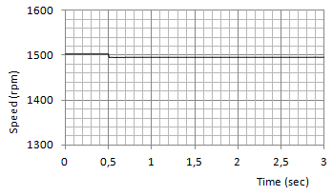  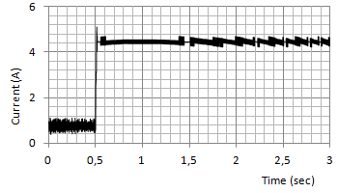
Figure 15. Load step change responses for the DC motor drive utilizing fuzzy based PI control.
Speed (rpm) and current (A) during motor load step change from a) 25% to 75% of rated load and b) 0% to 100% of rated load, at 0.5s in both cases.
a) | 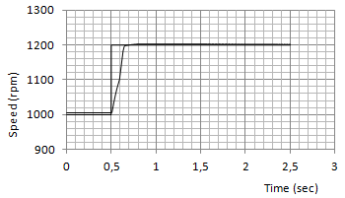  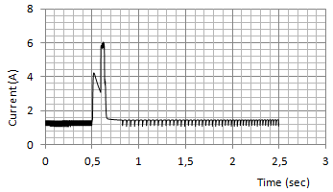 | b) | 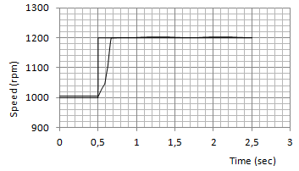  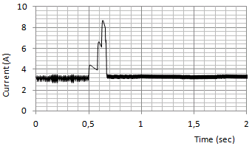
Figure 16. Speed step change response for the DC motor drive utilizing fuzzy based PI control.
Speed (rpm) and current (A) for motor speed step change from 1000rpm to 1200rpm for a) 25% of rated load and b) 75% of rated load, at 0.5s in both cases.

Conclusions
In this paper, a reliable conventional PI and a fuzzy based PI Controller for a separately excited DC motor are designed. The fuzzy based PI controller adjusts the proportional and integral (K_{p}, K_{i}) gains of the conventional PI controller according to speed error and change in speed error. The simulation of DC motor with PI and Fuzzy PI Controller has been conducted with the help of SIMULINK/MATLAB. The Speed characteristic of DC motor with these two controllers is recorded and their performance is evaluated on the basis of the following parameters. Maximum Overshoot, Delay Time, Rise Time, Settling Time. From the simulation results it is concluded that the self-tuning PI controller has better performance in both transient and steady state responses compared with the conventional PI one.

Acknowledgements
Research co-funded by the E.U. (European Social Fund) and national funds, action “Archimedes III–Funding of research groups in T.E.I.”, under the Operational Programme “Education and Lifelong Learning 2007-2013”.


References
Alloua, B., Gasbaoui, A.L.B., & Abderrahamani, A. (2009). Neuro-Fuzzy DC Motor speed Control Using Particle Swarm Optimization, Leonaro Electronic Journal of Practices and Technologies, 15, 1-18.
Ashraf, A.J. (2010). DC Motor Speed Control via Fuzzy / Pole Placement / PI Controller, June 2010, Master Thesis
Bansal, U.K., & Narvey, R. (2013). Speed Control of DC Motor Using Fuzzy PID Controller, Advance in Electronic and Electric Engineering, 3(9), 1209-1220,
Ioannidis, G.Ch., Psomopoulos, C.S., Kaminaris, S.D., Pachos, P., Villiotis, H., Tsiolis, S., Malatestas, P., Vokas G.A., & Manias, S.N. (2013). AC-DC & DC-DC Converters for DC Motor Drives: Review of Basic Topologies, International Conference on Electronics and Communication Systems 2013, Rhodes, Greece, pp.96-103
Ioannidis, G.Ch., Psomopoulos, C.S., Kaminaris, S.D., Vokas, G.A., Pachos, P., & Tsiolis, S. (2012). Energy Savings & Power Quality in dc Motor Drive Systems in the Hellenic Territory: Methodology & Early Results, 7th International Scientific Conference (e-RA 9), Archimedes Session, September, Egaleo, Greece, pp.65-77
Isermann, R. (1998). On Fuzzy Logic Applications for Automatic Control, Supervision, and Fault Diagnosis, IEEE Transactions on Systems, Man, and Cybernetics−Part A: Systems and Humans, SMC-28(2), pp. 221-235,.
Jantzen, J. (1998). Design of Fuzzy Controllers, Technical University of Denmark: Department of Automation, Technical report number 98-E 864, August, URL: http://www.iau.dtu.dk/
Lee, C.C. (1990a). Fuzzy Logic in Control Systems: Fuzzy Logic Controller-Part I, IEEE Transactions on Systems, Man, and Cybernetics, 20(2), pp. 404-418.
Lee, C.C. (1990b). Fuzzy Logic in Control Systems: Fuzzy Logic Controller-Part II, IEEE Transactions on Systems, Man, and Cybernetics, 20(2), pp. 419-435.
Natsheh, E., & Buragga, K.A., (2010). Comparison between Conventional and Fuzzy Logic PID Controllers for Controlling DC Motors, IJCSI International Journal of Computer Science Issues, 7(5), 128-134
Yager, R.R., & Filev, D.P. (1994). Essentials of Fuzzy Modeling and Control, New York: John Wiley & Sons.

