MEMS Acceleration Sensors for studying the Simple Pendulum in a General Physics Laboratory
P Amprachamian¹, A.Lazarou², K Yiasemides³, K Prekas⁴, P Papageorgas⁵ and K Zachariadou⁶
Department of Electronics Engineering, Piraeus University of Applied Sciences, P Ralli & Thivon 250, 12244 Egaleo, Greece.
¹panoscode@hotmail.com, ²alkis_7@hotmail.com, ³kyiase@teipir.gr, ⁴prekas@teipir.gr, ⁵ppapag@teipir.gr, ⁶zacharia@teipir.gr
Abstract
A data logger with embedded MEMS accelerometers and wired/wireless communication capabilities has been developed and applied for the study of a mathematical pendulum, a physical system suitable to provide an understanding of inertial and non-inertial reference frames to undergraduate students. The proposed system utilizes Matlab’s Fast Fourier Transform library for data analysis of the measurements of pendulum’s motion that is studied in the context of a General Physics Laboratory in an Electronics Engineering Curriculum. It is expected that the real-time collection and analysis of the experiment’s data using widely acceptable Software tools and appropriate electronics will motivate students to deepen into common physical phenomena. The real-time data acquisition and analysis pendulum platform realized has been partially developed in the context of a diploma thesis conducted in the Department of Electronics Engineering of the Technological and Educational Institute of Piraeus.

Keywords: Sensors, Accelerometers, General Physics Laboratory, Pendulum, Non-Inertial Reference Frame.

- Introduction
The pc-pendulum lab was developed as a broadly applicable assessment tool for undergraduate physics lab courses. It is aimed that the system will be validated and administered in all levels of undergraduate physics classes.
Traditional physics labs have focused on physics content and gaining familiarity with the lab equipment. Concerns about the pedagogical effectiveness of introductory physics labs and the attractiveness to the new technologies for students, have prompted the development of a pendulum lab based on a personal computer by integrating acceleration sensors, open source platforms like Arduino [1] for data acquisition and system control and processing with widely acceptable in the Academic community tools like Matlab [2.The main purpose of the system is to motivate the active involvement of students for experimentation in undergraduate physics laboratories by demonstrating and deepening into fundamental laws of physics using the appropriate sensing and processing tools.
The pc-pendulum has been partially developed in the context of a diploma thesis conducted within the Technological Educational Institute of Piraeus under the supervision of the Electronics Engineering’s Department Physics academic staff.

- The system layout
In the work that led to this thesis, two accelerometers have been used for the pendulum pc-lab. The two apparatus developed were designed to address the motion of a mathematical pendulum and evaluate the acceleration of gravity. Towards this aim it uses mathematical tools such as the Fast Fourier Transform and fitting techniques by integrating them into a friendly to the students graphical user interface (GUI) developed in Matlab. The main differentiation between the two apparatuses is solely the type of communication with the accelerometer sensor that must be embedded in the moving mass of the pendulum. The first realization is wired using very thin-wires used in constructing transformers for communication while only the MEMS accelerometer is embedded in the mass. The second realization is the wireless apparatus that consists of the Arduino nano platform, a Bluetooth transceiver and the MEMS accelerometer embedded in the pendulum mass. There are pros and cons of the two realizations that will be described in the following paragraphs.
Using the pc-pendulum lab, students will be able to perform the experiment, observe it in action and collect the data of interest. Since the whole experimental procedure is accomplished in a few minutes it’s possible for example to have an entire class of students performing this experiment with different parameters at the same time, such as varying the length of the pendulum in order to determine the acceleration of gravity by calculating the period of the pendulum. With the close to real-time performance achieved for experimentation, the students are actively participating to the effect of various parameters in the experiment’s results, and thus the deepening of their understanding is achieved about the Physic laws involved.
The pc-pendulum lab is based on and programmed in Matlab and in ROOT (a data analysis framework developed at CERN)[3] both running in a personal computer. The pc-pendulum apparatus architecture is described in the following sections.
2.1 The wired accelerator apparatus
The wired accelerator apparatus is based on a two-axis MEMSIC 2125 Digital accelerometer [4] (Figure 1), placed inside a carefully designed plastic ball (the pendulum mass) hanging from the appropriately realized wires for communication of the accelerometer to the data acquisition board using the SPI. This type of accelerometer use a chamber of gas with a heating element in the center and four temperature sensors around its edge. When the accelerometer is level, the hot gas pocket rises to the top-center of the chamber, and all the sensors measure the same temperature. However the tilting or movement of the accelerometer has as a direct effect the movement of the hot gas pocket and accordingly an asymmetry in the measurements of the temperature sensors. By comparing the sensor temperatures, both static acceleration (gravity and tilt) and dynamic acceleration are measured as signals (pulse durations) that are measured and decoded.

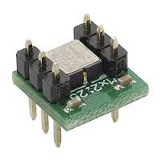

Figure 1. The MEMSIC 2125 accelerometer
The MEMSIC 2125 wired accelerometer is capable of measuring acceleration up to plus or minus 3g. It has a simple digital interface: two pins (one for each axis) emitting pulses whose duration corresponds to the acceleration of that axis. By measuring the length of that pulse (in microseconds) using the open source prototyping platform Arduino it is possible to determine the rate of acceleration. Figure 2 shows the experimental setup of the wired pendulum lab.
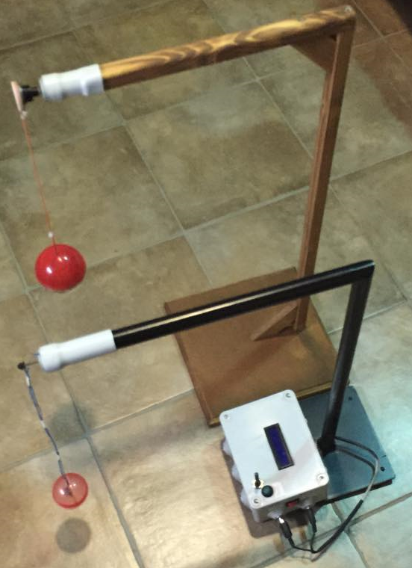
Figure 2: The wired accelerator apparatus

2.2 The wireless accelerator apparatus
The wireless apparatus is based on the accelerometer ADXL335 [5] capable of measuring acceleration up to plus or minus 3g. The ADXL335 is a typical MEMS accelerometer that is based on the movement of small structures that alter the capacitance of the signal conditioning system realized. The ADXXL335 is a System On Chip implementation with the sensor and the signal conditioning electronics integrated in a Chip with three analog outputs for the three-axis orthogonal accelerometer signals measured. These signals are digitized with the ADC integrated in the Arduino platform and used for processing. The wireless communication is realized using an HC-05 Bluetooth module [6.] that can support wireless connectivity with any commercially available Bluetooth device. The microcontroller platform is based on the open source Arduino Nano that supports the data acquisition and the control of the acceleration sensor, as well as the transmission of the data collected through the Bluetooth transceiver. The microcontroller platform, the accelerometer sensor and the Bluetooth transceiver has been embedded with a battery in carefully designed plastic ball (Figure 3) that is the pendulum mass.
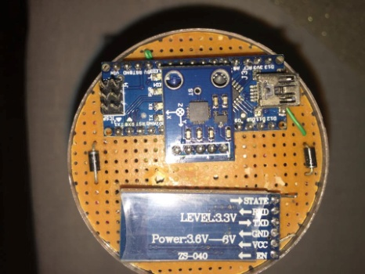
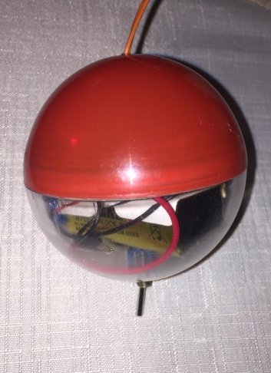

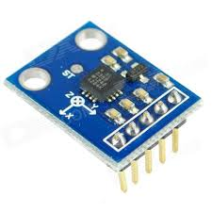
Figure 3. The wireless accelerator apparatus embedded in the house ball

Figure 4. The ADLX 334 accelerometer.
2.3 The Graphical User Interface (GUI)
A Graphical User Interface (GUI) (Figure 5) has been developed for both apparatus
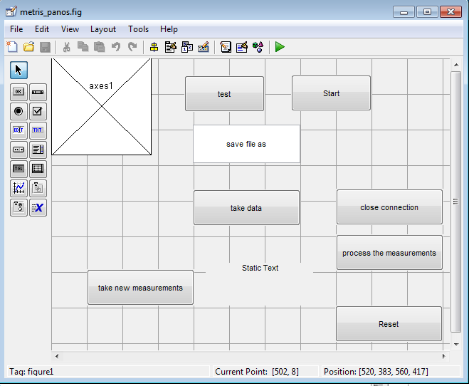

Figure 5. The Graphical User Interface (GUI).
using Matlab. The GUI is designed to start and stop the data acquisition, to save the data, to display the data and to run the Fast Fourier Transform code.

- Experimental results
Using both apparatuses the pc-pendulum lab has been extensively tested to oscillate with minimum twists and friction around the pivot point. Special care has been taken for minimizing the friction effects for both apparatuses using SKF ball bearings in the support cable. The motion of a mathematical pendulum is depicted in Figure 6.
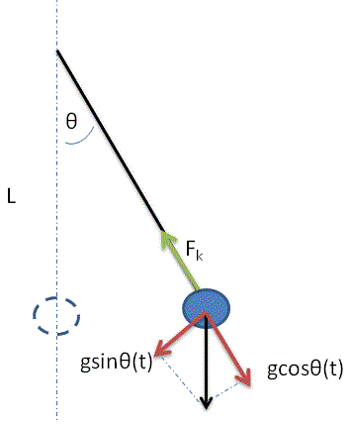

Figure 6. The mathematical pendulum
The recorded acceleration in g-units both in y (perpendicular) and x (horizontal) axis is shown in Figure 7a and Figure 7b respectively. The pendulum has been released from rest and the length of the USB cable between the pivot point and the ball’s center of the weight is measured to be approximately 30cm.
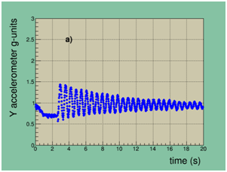
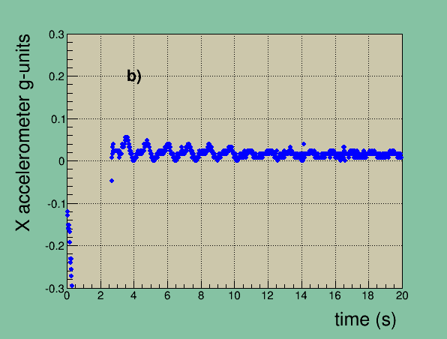

Figure 7. The acceleration of the pendulum mass in g-units a) perpendicular to the motion (radial acceleration) and b) parallel to the motion (tangential acceleration).
Shown in figure 8 is the frequency domain plot of the radial acceleration. The FFT has been performed by using 1024 points. The primary mode of the pendulum at 2 Hz is clearly visible. Since the frequency is twice that of the angular position θ(t), the period of the oscillations is evaluated to be T=1.1 s. Given that for small amplitude oscillations the period is described by the simple formula:
(1),

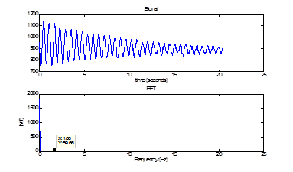
Figure 8. Frequency domain spectrum of the radial acceleration
In order to evaluate the acceleration of gravity 100 measurements have been performed using the wireless pendulum. Shown in Figure 9 is the histogram of the measurements and the fit with a Gauss function. It can be noticed that the fit to the histogram is excellent giving a value for the acceleration of gravity:

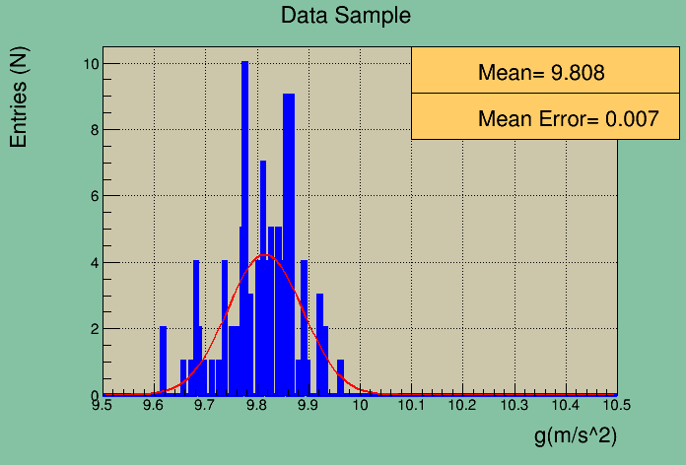
Figure 9: Histogram of the measurements for the evaluation of g. The histogram is fitted with a Gauss function.

- Conclusions

A pc-pendulum laboratory has been developed based on both a wired and a wireless accelerometer, in the framework or a diploma thesis [7] of one of the authors of the current article. The diploma thesis has been conducted within the Piraeus University of applied under the Electronics Engineering Department’s academic staff.
Both the wired and the wireless accelerometer has been integrated into a specially designed plastic ball hanging from a stable pivot point. Both systems are controlled from a Graphical User Interface developed in Matlab.
The wired accelerometer apparatus has as a benefit that only the accelerometer sensor must be embedded in the pendulum mass, while on the cons of this approach is the complexity of designing and taken care of very thin wires for communication and power transmission.
The wireless accelerometer apparatus has as a benefit that wireless connectivity with every Bluetooth device can be supported, while on the cons of this approach all the parts (microcontroller platform, communication module, accelerometer sensor and battery) must be embedded in the pendulum mass affecting the designed experiment specifications.
In the near future and according to the Moore’s law wireless realizations as the described one will have dimensions and weight appropriate for prevailing in designing such experiments in comparison with the wired ones.

- References

[1] Arduino http://www.arduino.cc/
[2] Matlab http://www.mathworks.com/products/matlab/
[3] ROOT http://root.cern.ch/drupal
[4] https://www.parallax.com/product/28017
[5]
http://www.analog.com/en/products/mems/mems-
accelerometers/adxl335.html#product-overview
[6]http://wiki.iteadstudio.com/Serial_Port_Bluetooth_Module_(Master/Slave)_:_HC-05
[7] Amprachamian Panagiotis,Lazarou Alkiviadis “Engineering and physics experiments running platform, supported by mobile computing and wireless local area networks technologies.”, Athens 2015

